**DentalPro Supply SQL & ERD System**

# 1. Introduction & Background

In this project, I developed a database system for a dental equipment supplier named *DentalPro Supply*. The business supplies a wide range of professional-grade dental products, including dental chairs, handpieces, Personal Protective Equipment (PPE), and various dental materials.

I chose this sample data and business theme based on my family's real-world clinics experience. My husband, who operates a dental clinics, supported me in identifying the types of products commonly used in practice, which helped guide the structure and content of the inventory and supplier data.

The objective of the project was to build a database that could manage customer (clinic) information, product inventory, orders, payments, and returns. Additionally, a data mart was developed to support business reporting, such as order tracking, stock level monitoring, and supplier performance analytics.

# 2. ERD Diagram

The Entity Relationship Diagram (ERD) and overall database design reflect the structure required to manage a dental supply business efficiently, the database includes the 6 required tables **stock, customer, orders, suppliers, payments,** and **returns**, to improve functionality and normalisation I add three tables **categories** (to classify dental products), **order_items** (to support multiple products per order), and **staff** (to track which team member processed each order and return) in total my database contains 9 tables. Relationships follow normalisation principles, such as one-to-many connections between **customers** and **orders,** **suppliers** and **stock,** and **staff** to **returns**. The **order_items** table resolves the many-to-many relationship between **orders** and **stocks**, ensuring efficiently expandable clean data management.

# 3. Sample Data

After created the 9 tables successfully the sample data for all main 9 tables, was generated using Mockaroo. Custom lists and formulas were applied to reflect realistic operations within a dental supply business. Products such as autoclave pouches, gloves, dental chairs, and filling materials were included to simulate an authentic inventory.

The following screenshot shows the successful creation of the 9 tables using SQL pgAdmin 4.

Below is a summary of the tables populated, and the volume of records generated. Screenshots of sample records from each table have been included below to demonstrate successful data insertion using pgAdmin 4.

1. **CUSTOMERS** table with 30 recordsA screenshot of a computer

   AI-generated content may be incorrect.
2. **STAFF** table with 8 recordsA screenshot of a computer

   AI-generated content may be incorrect.
3. **STOCKS** table with 150 records A screenshot of a computer

   AI-generated content may be incorrect.
4. **ORDERS** table with 100 records A screenshot of a computer

   AI-generated content may be incorrect.
5. **ORDER_ITEMS** table with 150 records A screenshot of a computer

   AI-generated content may be incorrect.
6. **SUPPLIERS** table with 10 records A screenshot of a computer

   AI-generated content may be incorrect.
7. **CATEGORIES** table with 6 records A screenshot of a computer

   AI-generated content may be incorrect.
8. **PAYMENTS** table with 100 records A screenshot of a computer

   AI-generated content may be incorrect.
9. **RETURNS** table with 20 records A screenshot of a computer

   AI-generated content may be incorrect.

# 4. Query Results

This screenshot shows the three views created under the dentalpro_datamart schema.

Including weekly transactions, stock purchased by supplier, and total stock sold by supplier.

## Query 1

This view lists all transactions that happened in the past 7 days, it includes order details such as order id, order date, I concatenated first name and last name to get customer name, product purchased, quantity, total price, payment type, and payment date. It is useful for weekly sales monitoring and transaction tracking

## Query 2

I created trigger name after_order_item on the order_items table every time a new order item is added like sale is made, the trigger runs a function called log_stock_level which records the current stock level of the sold item into an audit table called stock_audit.

The screenshot shows confirm that the trigger captures stock levels correctly each time a sale occurs that means the trigger working as expected.

## Query 3

This view screenshot displays the stock items grouped by supplier. It includes the supplier name, product name, price, and quantity in stock.

## Query 4

This view screenshot shows the total quantity of stock sold, grouped by supplier and product, it aggregates all sales data to give an overview of which suppliers products are performing best.

## Query 5

This screenshot shows the total quantity sold and sales value for each product during the current month.

## Query 6

The screenshot shows a detailed of all sales for the current year, grouped by month and product.

## Query 7

This screenshot shows the calculation of total sales per month and computes the growth percentage compared to the first recorded month.

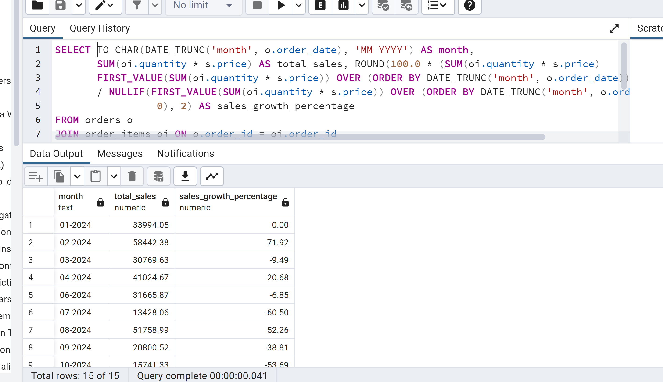

## Query 8

This screenshot lists all product returns recorded to date, including details such as return reason, refund amount, product name, and customer information.

# 6. Summary

This database structure provides full coverage for managing dental product sales and logistics with features like multi-product orders, real-time stock monitoring, and return tracking, it ensures operational efficiency for both suppliers and clinics. Views and scripts were created to support business reporting.